Crust to Core: An Introduction to Perple_X - Exercises

Exercise 1:
- Use build, vertex and pssect to produce a pseudosection for a simplified pelitic rock composition (in molar proportions: 3.82 % K₂O, 10.53 % FeO, 4.76 % MgO, 12.49 % Al₂O₃, 68.00 % SiO₂) at 2 – 15 kbars, 450 – 700 ˚C. Use the supplied Holland & Powell (“hp02_ver.dat”) end-member datafile, the “solut_09.dat” solution models file and the “perplex_option.dat” file.

Assume that H₂O can be set in excess and calculate for the following phases with solid solutions:

Bio(HP) [biotite]
Chl(HP) [chlorite]
St(HP) [staurolite]
Ctd(HP) [chloritoid]
hCrd [cordierite]
Gt(HP) [garnet]
Pheng(HP) [muscovite/phengite]

Suggested answers to the build questions are attached and will be explained further. The calculation structure is build (to define the calculation) → vertex (to run the file made by build) → pssect (to make a PostScript file from the vertex output). The PS file can be opened in Ghostview, Adobe Acrobat, Reader or Illustrator, or the Corel programs).

Notice that additional phases (sill, ky, and, q) are automatically included. They can be suppressed (if desired) in the build questioning.

The result is a little disappointing. Understanding the gridded minimization strategy, the pseudocompound approximation, and the auto refine strategy will help to fix this.

- Copy and paste all of the existing files to a new folder and modify the “perplex_option.dat” file there to increase both the resolution of the xy grid and number of levels of refinement of this grid (suggested number of x and y nodes after auto-refinement = 100 and number of grid-levels = 4). Note that you then need to run vertex and pssect again, but do not need to remake the build file.

- The xy grid looks fine now but the assemblage boundaries look a little strange… Copy your results to a 3rd folder. Then increase the compositional resolution defined in option file (“perplex_option.dat”) to improve this (suggested auto_refine_factor_I = 4, iteration = 4 3 10).

Notice that the number of pseudocompounds generated now far higher than previously and that the vertex calculation takes much longer to run.

- This looks good now but we missed out some important components. Add 1.5 % Na₂O and 1.5 % CaO to the ‘rock’ and calculate with two additional solution models:

Omph(HP) [omphacite]
Feldspar [obvious]

Run vertex. Notice that (i) we did not specify any change to the garnet model but it automatically now includes a Ca-end member, (ii) likewise, phengite now automatically includes Na mixing on the A-site, (iii) the calculation takes significantly longer because of all of the new pseudocompounds.

How do the KFMASH and NaCaKFMASH results compare? What is the significance of the two “Omph(HP)” phases at high pressure, low temperature (e.g. 723 K, 13 kbars)?

Exercise 2:
Calculate a pseudosection for hydrothermally altered metabasalt with the composition Na₂O 2.07; MgO 6.66; Al₂O₃ 15.53; K₂O 0.56; CaO 12.88; FeO 10.02; SiO₂ 45.8; H₂O 2.68; CO₂ 2.95 (amounts in wt %). Use the hp02ver.dat database again, and the CORK equation of state for water and CO₂.

Calculate in the range T = 400 – 1000 ˚C and P = 10 – 80 kbar. Do not specify fluid or component saturation and exclude the following end-members:

cz [clinozoisite]
afchl [aluminium-free chlorite]
odo [ordered dolomite]
h2oL [a special end-member for granitic melt]
Use the solute_09.dat solution file again, selecting the following models:

Bio(HP) [biotite]
Chl(HP) [chlorite]
Gt(HP) [garnet]
Mica(CH2) [white mica]
San [alkali feldspar]
Pl(h) [plagioclase]
Amph(DPW) [clinoamphibole]
Omph(HP) [clinopyroxene]
Opx(HP) [orthopyroxene]
Do(HP) [dolomite]
M(HP) [magnesite]
T [talc]
F [fluid]
Note that this calculation is essentially the same as that outlined in Jamie’s tutorial at perplex_seismic_velocity.html (see also Kerrick & Connolly, 2001). We can use diagrams such as this to answer some interesting questions:
- Where does the metabasalt begin to devolatilize?
  - Use werami (mode 2) to compute the fluid fraction produced as a function of P and T.
  - Use pscontor to convert the werami output (“cpl”) into a contour plot. If you have Matlab, you can use the manually_labelled script to produce a coloured plot.
  - The output is in weight percent fluid. You can change relevant keywords in “perplex_paramters.dat” so that werami outputs volume proportion instead.

- What is the composition of the fluid produced?
  - Use werami (mode 2) to compute H₂O / (H₂O + CO₂) as a function of P and T.
  - Plot it again with pscontor or Matlab.

- What v_{P} and v_{S} velocities are predicted, and how does the v_{P}/v_{S} ratio change as a function of P and T? Does this seem reasonable?

- Approximately what depth is lawsonite stable to for the subduction zone thermal structures in the following image? You will need to consider both the stability of lawsonite as a function of P and T and estimate bulk rock densities to calculate depth (P = ρgh). Again, this requires werami. You can also use werami mode 1 to output properties at particular P and T conditions.

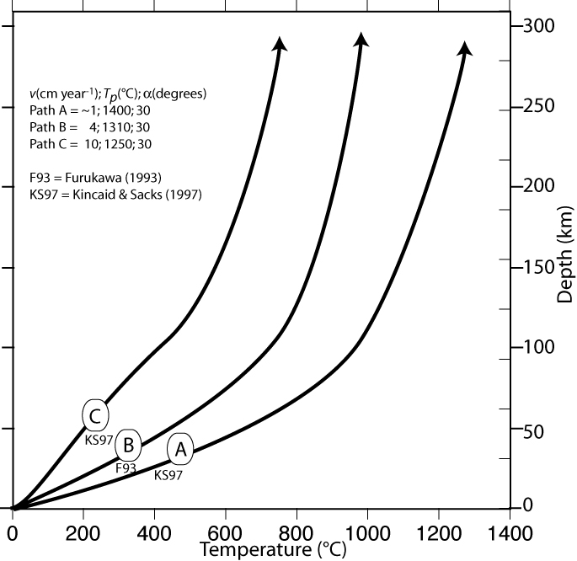
After Hack & Thompson (2009)

Exercise 3:

It is well known that MnO stabilises garnet at relatively low pressures and temperatures. TiO₂ may stabilise biotite at high temperature and is essential for stabilising numerous accessory phases.

- First calculate a pseudosection for an ‘average pelitic rock’ with (in weight percent):

Na₂O (1.73 %), MgO (2.62), Al₂O₃ (16.57) K₂O (3.53), CaO (1.09), FeO (5.81), SiO₂ (59.80)

Calculate at 673 – 973 K and 1000 – 15000 bars, with water in excess, using ‘hp02ver.dat’, ‘solut_seville.dat’, and the solid solution phases:

TiBio(HP) [biotite with a Ti-bearing end-member]
Chl(HP) [chlorite]
St(HP) [staurolite]
Ctd(HP) [chloritoid]
hCrd [cordierite]
Gt(HP) [garnet]
Mica(CH2) [muscovite/paragonite]
feldspar [plagioclase–K-feldspar]
Omph(HP) [omphacite]

There are quite a few components and complex solution models, so think about the resolution parameters so that this does not take too long.

Notice when running vertex that several end-members are not stable for the biotite model, because MnO and TiO₂ are not present in the bulk-composition.

- The code for the garnet, chloritoid, staurolite and cordierite models in ‘solut_seville.dat’ does not consider Mn-end-members (the chlorite and biotite models do). Copy all of the calculation files into a new folder and re-formulate these solution models to include to following end-members:

spss [spessartine for the garnet model]
mnst [Mn-staurolite]
mnctd [Mn-chloritoid]
mncrd [Mn-cordierite]

The first 3 solutions only require mixing an additional species on the single site. Cordierite is more complex because in addition to Mn–Mg–Fe mixing on the 2 ‘M’ sites, there is also either H₂O or a vacancy on the 1 ‘H’ site. A table of the end-members required (including ‘dependent’ end-members) is given in the existing model. Assume ideal interactions between the new and existing end-members with the exception of:

W_{py,spss} 4500 J mol⁻¹ + 0P + 0T
W_{alm,spss} 240 J mol⁻¹ + 0P + 0T

- Re-calculate the ‘average pelite’ pseudosection with your four new models and with the addition of MnO (0.2 %), TiO₂ (0.75 %). You can also add an additional phase to the calculation:

IlGkPy [Mn-bearing ilmenite]

Although comparison of this diagram with the previous one gives some indication of the importance of the additional components, it might be more instructive to plot an isobaric diagram showing temperature on the y axis and a compositional variable on the x axis. You can do this by running build as previously - when asked to select an x-axis variable, choose option 4. The y-axis should be temperature (673 – 973 K). Try a diagram at 7000 bars, with a Y(CO2) sectioning value of 0 (pure water). You will be asked to give TWO bulk compositions (C0 and C1 for the left and right axes, respectively), try:

C0 C1
Na₂O 1.73000 1.73000
MgO 2.62000 2.62000
Al₂O₃ 16.5700 16.5700
K₂O 3.53000 3.53000
CaO 1.09000 1.09000
FeO 5.81000 5.81000
SiO₂ 59.8000 59.8000
MnO 0.00000 2.00000
TiO₂ 0.750000 0.750000

Run the diagram as normal with vertex and then pssect. Notice that although only the bulk-rock MnO content varies from left to right, the stabilities of phases that do not even include MnO (e.g. rutile) can be affected. This is discussed further in Caddick & Thompson (2008). Werami could also tell you how the compositions of co-existing phases various as a function of bulk-rock composition.

Exercise 4:

Try calculating the wet solidus for melting of the pelitic rock in exercise 3, using the Melt(HP) solution model. Hint: Think about how you treat water…

How does the composition of the melt produced vary as a function of depth and temperature?

Optional exercise 5:
For the system configuration in Exercise 2, set up a phase fractionation calculation to evaluate the amount and composition of fluid that evolves during subduction along a (moderate) geotherm defined by the polynomial: P(bar) = 69260 − 135 T + 0.103 T² for T = 673-1473 K. Compute the fluid composition and the weight fraction of CO₂ and H₂O retained in the solid residual as a function of pressure to visualize the devolatilization process in each scenario.

Optional exercise 6:
For the system configuration in Exercise 4, set up a phase fractionation calculation to produce and remove melt from the pelitic protolith (along a P–T path of your choosing). How does the residual phase assemblage change from that predicted in the diagram produced in Exercise 4? What does this do to the average density of the bulk-rock?

Optional exercise 7 (from Jamie’s Bayreuth course):
Use the high pressure CaO-MgO-FeO-Al₂O₃-SiO₂ thermodynamic data-base ‘sfo05ver.dat’ (Stixrude & Bertolloni 2005, Khan et al. 2006) to compute densities for pyrolite and MORB for P = 1 – 130 GPa, T = 1273 – 3273 K. For pyrolite and MORB the molar proportions of oxides are (3.50 : 5.72 : 48.53 : 1.795 : 38.66) and (1.54 : 1.14 : 1.56 : 0.98 : 6.61) respectively. Use the ‘solute_09.dat’ solution model file and select the models: Wus(fab), Pv(fab), Ppv(og), O(stx), Wad(stx), Ring(stx), C2/c(stx), Opx(stx), Cpx(stx), Sp(stx), Gt(stx), Aki(fab). How do the relative rock densities compare at depth?
The Mn-absent model for hydrous/anhydrous cordierite

begin_model
ideal anhydrous/hydrous Mg/Fe HP cordierite model.

M H
________________

Mutliplicity 2 1
________________

1 mncrd Mn Vac
Species: 2 fcrd Fe Vac
3 crd Mg Vac
4 hmncrd Mn H2O dependent
5 hfcrd Fe H2O dependent
6 hcrd Mg H2O
_______________

Dependent: hfcrd = hcrd + (fcrd - crd)

hCrd
7 model type: reciprocal
2 2 reciprocal sites
2 2 3 species on site 1, 2 on site 2
fcrd crd
hfcrd_i hcrd

1 1 dependent endmember

hfcrd_i = 1 hcrd + 1 fcrd - 1 crd

0 0 0 0 | endmember flags

| Note restricted range on X(Mn)

0. 1. .1 0 | range and resolution for X(Fe) on M site, imod = 0 -> | cartesian subdivision

0. 1. .1 0 | range and resolution for 1-X(H2O) on H site, imod = 0 | -> cartesian subdivision

ideal

2 2 site entropy model.

2 2. 2 species on M, 2 sites per formula unit.
z(m,mg) = 1 crd + 1 hcrd

2 1. 2 species on H, 1 sites per formula unit.
z(H,H2O) = 1 hcrd

end_of_model

